**Heart Failure Prediction Using Auto AI Feature**

**Project Idea:** Cardiovascular diseases(CVDs) are the number1 cause of death globally, takingan estimate 17.9 million lives each year, which accounts for 31% of all deaths world wide.

**Solution:**

Heart failure is a common event caused by CVDs and this dataset contains 9 features that can be used to predict mortality by heart failure.in this Project you need to build a model using Auto AI and build a web application where we can get the prediction of heart failure.

**Artitecture:**

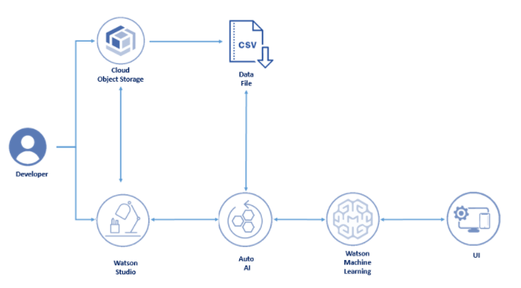

**Software Required:**

**.** IBM Cloud

. IBM watson Studio

. IBM watson Matchine learning

. Node-Red

. IBM Cloud Object Storage.

**Experimental Investigations:**

**.**create a IBM Watson studio

.Create a Machine learning Model

.Train the Model

.Deploy The Model

.Integrate to Node-Red Application

.Predict the Output

**i)Create a IBM watson studio:**

First we need to login the IBM cloud.and we need to go to the dashboard.There we need to search for the watson service.click on that then fill the required contents then create the service.the below you find the created image.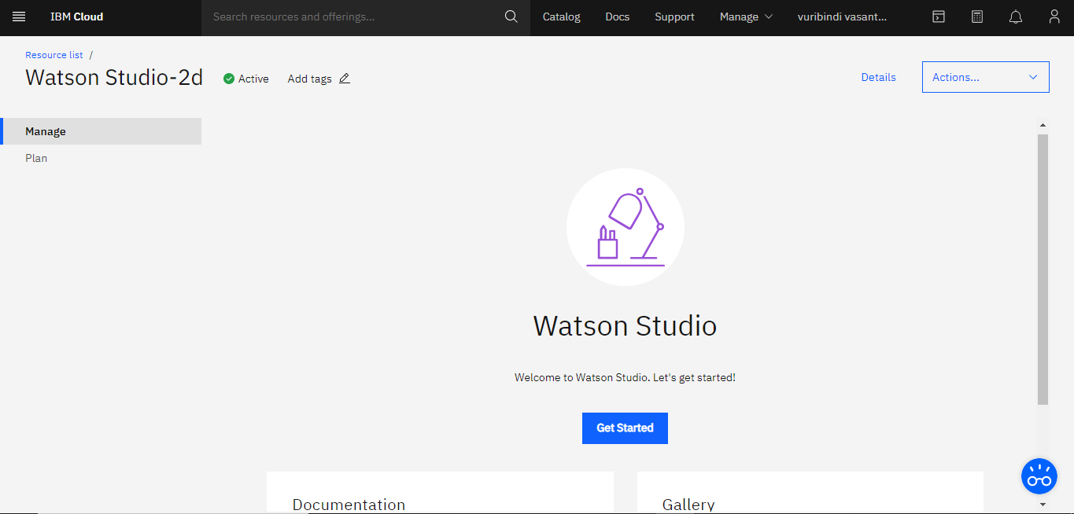

**ii)Create a Machine learning Model:**

same process will be followed for this machine learning also but we need to store this in cloud object storage(cos).the landing page will be below.

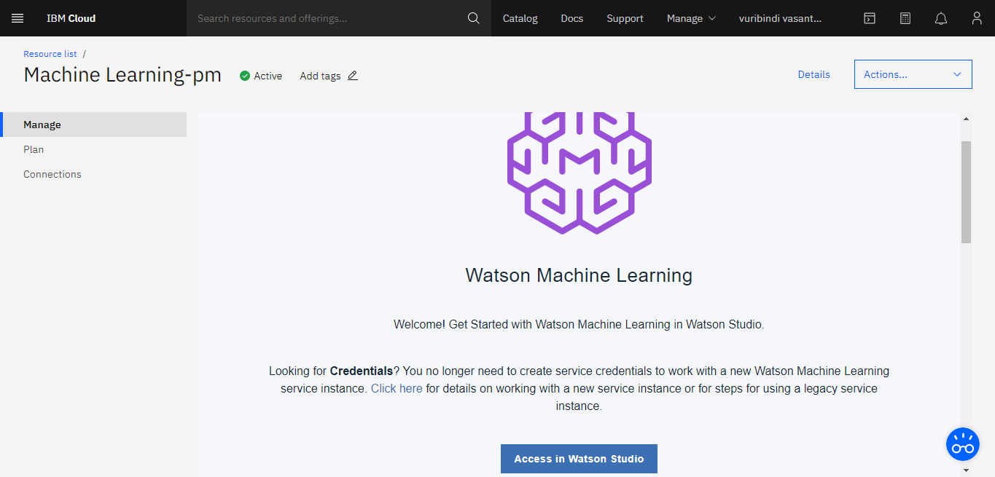

**iii)Train the model:**

in this Task we need to use of the above 2 services to proceed further.The below is the Trained model of our project.

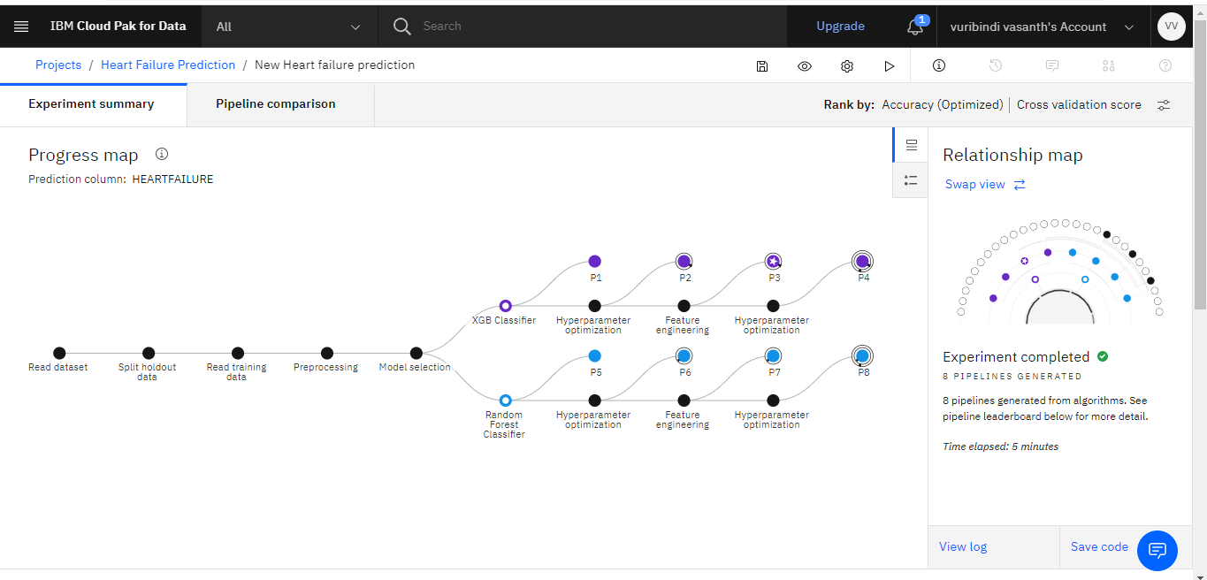

This the project summary

**.** Now ill mention the pipelinecomparision in it.The below mentioned fig.

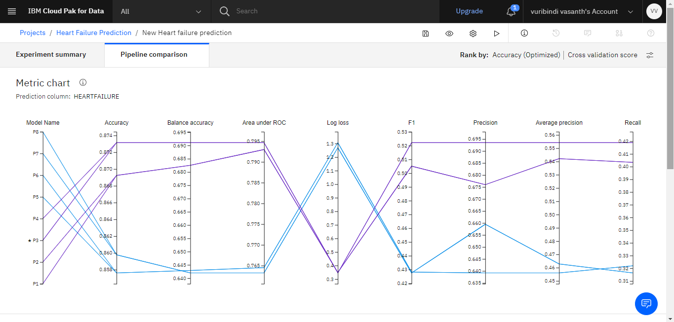

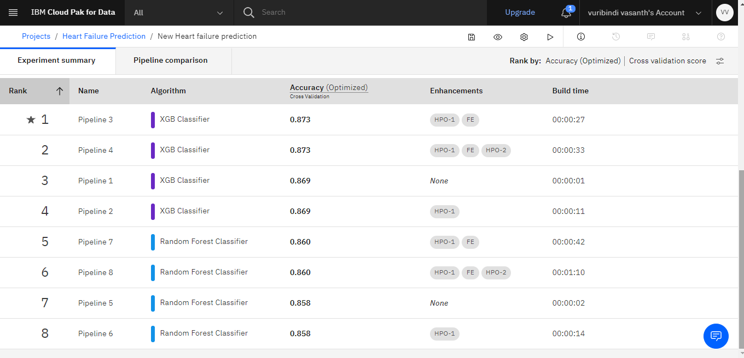

**iv)Deploy the model:**

After Trained the model and pipeline comparison.we need to save as a model.And we are ready to go.Now we need to deploy that model.The deployed Model will showed like this as below.

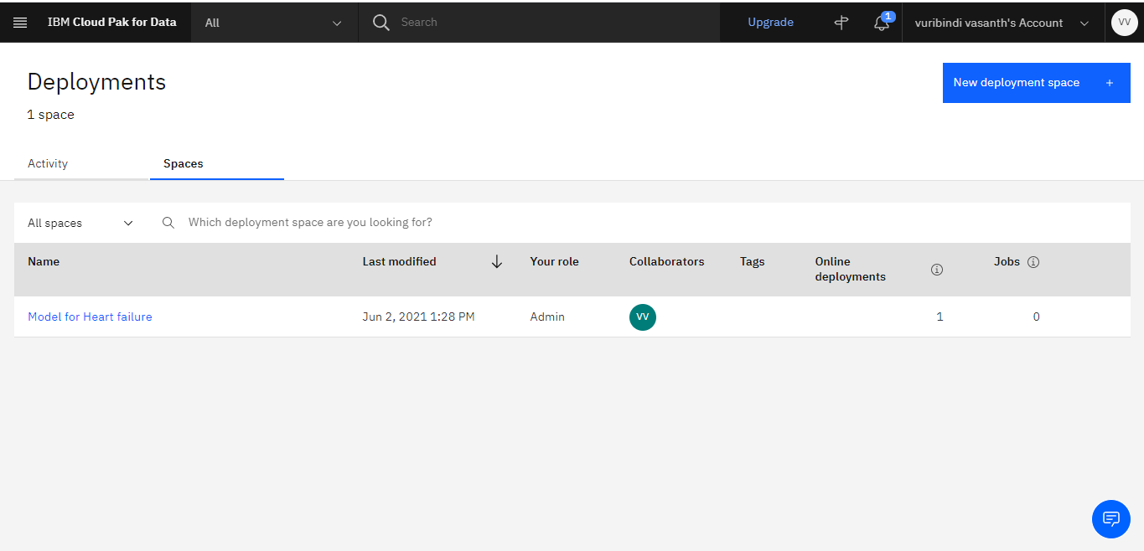

**v)Integrate to Node-Red Application:**

Now,we need to integrate the deployed model to Node-red application for that we need to Create a Node-Red cloud foundary app.after creating it will shows like as mentioned below.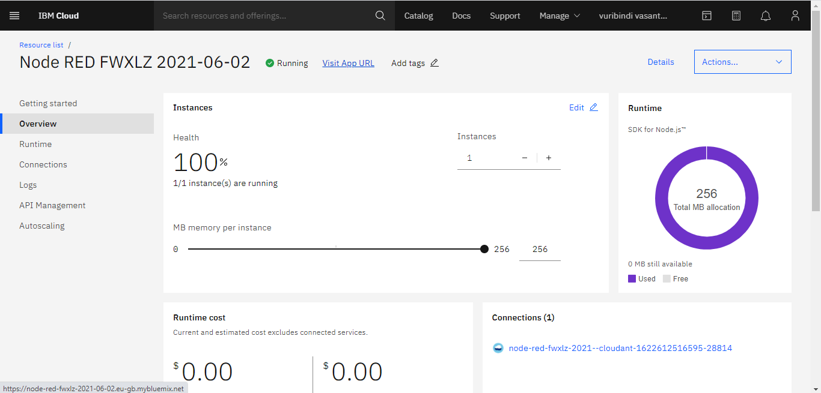

. Now we need to click on visit UrL we need to landed to the below pagesas shown.

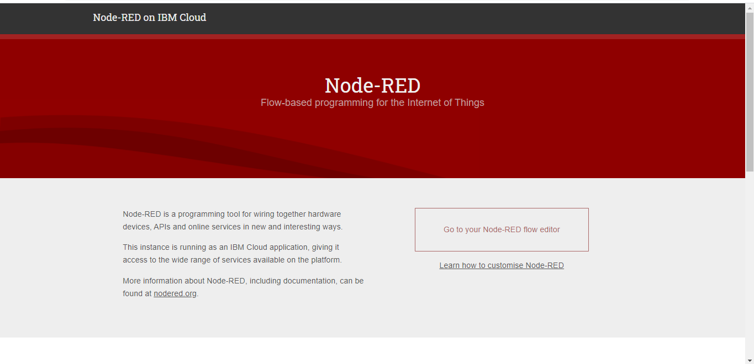

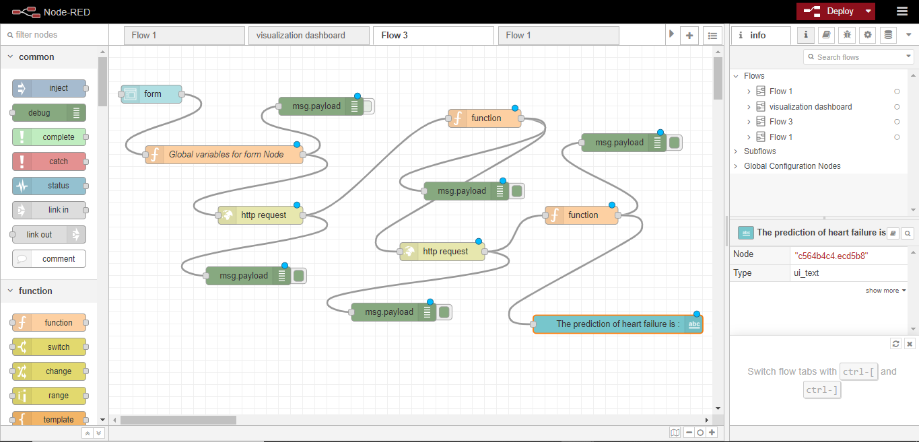

**vi)Predict The Output:**

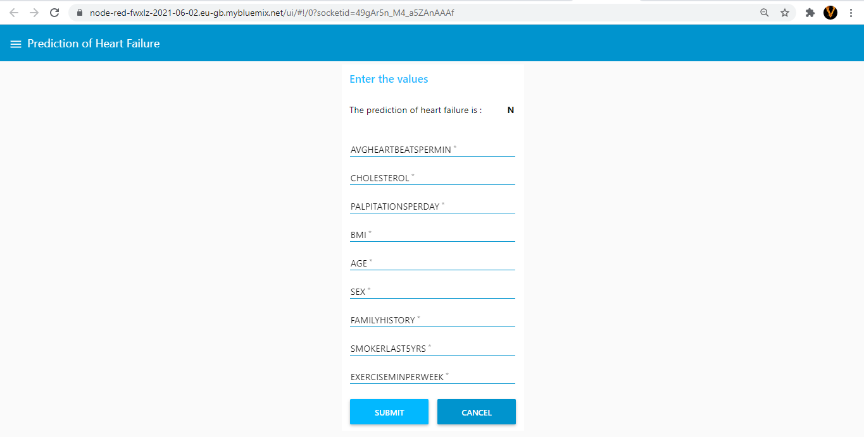

This is the final prediction of Our Project.